Twitter and the Inception of Political Revolts
G. R. Boynton
University of Iowa

Abstract
In the spring of 2011 revolt swept through North Africa and the Middle East. New media were used extensively by the persons engaged in revolt. This paper examines the way Twitter messages were used. I argue that in addition to other uses the practice of retweeting helped constitute communities of action for facing the tyrants. The use of retweeting is explored in messages containing #feb14, #Lybia, #Syria, and #Yemen. The analysis is augmented by moving to a different culture to examine retweeting in the revolt in Wisconsin. Given the exceptional use of retweeting in these situations of revolt the argument is well supported.
Twitter and the Inception of Political Revolts
It was called 'Arab spring.' It was revolt against established authorities that swept across North Africa and the Middle East. This was the aspiration for revolt articulated by one Twitter user.
RT @samiran Protests schedule, Bahrain #feb14, Libya #feb17, Algeria #feb19, Morocco #feb20, Cameroon #feb23, Kuwait #Mar8 ¹
@samiran included a number of revolts that did not take off, and missed Syria and Yemen. But they had dates; they hoped for a sweep of revolt.
After the 'spring' of 2011 some of the revolts had proved successful, some unsuccessful, and others were still in motion. It is difficult to write about events that are still in motion, but that is not the ambition here. The paper is about the inception of these revolts and the role that Twitter played as the revolts were starting.
Revolts against tyranny have a long history. What distinguishes these revolts is that they are among the first to happen in the context of the new generation of communication technologies, which are often called new media. The people revolting regularly used YouTube to show the world what they were revolting against. They used Facebook and Twitter to organize themselves and to reach out to the world to express their concerns. The journalists of the new media were particularly interested in the use of the new media for these political purposes, and I collected their accounts at Information Technologies and Political Rights; see pages 12 through 18 for the coverage during the early spring. They wrote about this in more detail and with a somewhat different perspective than found in more mainstream reporting.
This paper is an argument that there was an important use of Twitter messages that has not been as widely noted as: 1) use for organization and 2) for reaching out to the world. The paper begins by recounting the articulation of the revolt by Twitter users in Bahrain. That is followed by looking at Twitter use at the early stages of revolt in a number of countries. And that is followed by tracking counts of Twitter use from the early stages to June1, 2011.
Bahrain
Why Bahrain? It played a pivotal role in the sweep. Tunisia and then Egypt were successful. Bahrain was next; it showed that this was not a revolt limited to two countries, but was spreading to the entire cultural region. It is also a more highly networked society than the others in this sweep. More than eighty percent of Bahrainians have an internet connection. (Internet World Stats) The communication using the new media had the potential to reach almost the entire population of the country. That gave it a centrality to the revolt that was not as characteristic of other countries. And as Al Jazeera noted, "This is the Arab revolution that was abandoned by the Arabs, forsaken by the West and forgotten by the world." (Al Jazeera, August 4, 2011) It is well to remember this poignant moment in the history of Arab spring.
All of the Twitter messages quoted are taken from a search for the hashtag #feb14 beginning February 15, 2011 and continuing well past the point at which this paper stops.² Thus all the messages will contain #feb14 as an assertion of revolt.
RT @Ghonim The Power of People is much STRONGER than The People in Power #Bahrain #Feb14
RT @Bahrainiac: First they ignore you, then they laugh at you, then they fight you, then you win #bahrain #feb14
This was the central theme of the communication in the revolt in Bahrain. It is people versus tyrants. The people can exercise power that is greater than the tyrants can assemble. Even though they ignore you and laugh at you and then fight you -- you win. It is the people, the community acting together to assert themselves against the tyrant who can be successful. It is a we, the people, acting and not an I or plural I’s acting alone.
That does not mean it will be easy.
2/15/2011 RT @Jnoubiyeh: Confirmed Deaths In #Bahrain: 8-year old Hasan Mahdi, 25-year old Mohammad Saade and 27-year old Ali Mushaimi. #Feb14 #Bahrainis #Manama
Rulers do not go voluntarily. There is likely to be bloodshed and death along the way. On February 15 there were already two confirmed deaths: a child and a young man. But if they persevere the numbers are overwhelming.
That revolts are episodic in time is explained by people being generally more interested in their daily lives than they are in reforming the state.
2/16/2011 10:27 PM RT @RshRsho: RT @nadooi_wish: The protests were saying: "With soul, with blood, we live for Bahrain" And they were attacked by the army? #Bahrain #Feb14
But there may come a time when one's daily life is not enough. "We live for Bahrain." The tyranny is no longer acceptable, and the community acts together even though they are attacked by the army.
Even if it is we who are acting someone must go first, someone must be in front. That is a threatening position, and this was their way of dealing with the danger.
2/27/2011 7:35 AM Female speaker "I am here, I will not go anywhere. I will fight and my weapon is peace" #bahrain #feb14
2/26/2011 1:46 PM RT @maryamalkhawaja: "if it wasn't for the martyrs we wud not be here today, they have freed the detainees and wil free the rest" #martyrssquare #bahrain #feb14
If you step out and the revolution is a success you will be a hero. Very likely a dead hero, a martyr, since those who lead are the ones most likely to feel the wrath of the rulers.
To overwhelm the rulers a community of action must come into play. And this is how they said it.
2/26/2011 3:49 PM RT @Bahrainiac: 40% Of Bahrain's Entire Population Attends Latest Protest http://wp.me/p1jYBG-1eD #Bahrain #feb14
2/27/2011 11:26 AM RT @maryamalkhawaja: Chanting "no Sunni no Shias, but a nation demanding freedom" #martyrssquare #bahrain #feb14
There must be the sense that you do not have to look over your shoulder to see if someone is following. Everyone was there. That, of course, is possible only in a small island kingdom like Bahrain. But 40% could be there. And they were not divided; no sunni and no shia. While the tyrants were portraying the revolt as sectarian the people were denying it. We are acting together, they said.
2/16/2011 7:31 AM RT @maryamalkhawaja: News tht gov thugs are gathering ppl for pro gov rally to bring them to "create disturbances, but we will meet them with roses" cont. #feb14
2/15/2011 10:13 PM RT @aslanmedia: Take a closer look at where the "#Egypt effect" is spreading. http://ow.ly/3X9MO #jan25 #feb14 #feb12
And when you act together you can win. "We will meet them with roses." And that is where the "#Egypt effect" is important. If they could walk together and win so can we.
That is the story of Bahrain as they told it. A community living for Bahrain. Rising up together. But the Saudis brought additional military might and the power of the people was not greater than the military force they faced.
The first weeks, the inception, there was great hope and great excitement as reflected in the Twitter messages quoted. And messages streamed from the people to the people of Bahrain and to the people of the world.
[Figure 1 here]
There were only a few thousands messages the first couple of days, and then there was a flood: 35,000 on the sixteenth, 35,000 on the seventeenth, and 30,000 on the eighteenth. Then 10,000 on the nineteenth, and between 10,000 and 5,000 through the twenty-third. For the first two weeks, February 14 through February 28, the total was 153,309 messages posted to Twitter. In a small island kingdom with a population of 1.2 million that was a flood.
What were they saying in their messaging? Much of the discussion of the new media and these revolts has centered on two uses.
One use has been organizational, coordinating the activity of the protestors.
2/15/2011 11:57 PM RT @AJELive: Anti-government demonstrators in #Bahrain to stage fresh protests in around 30mins from Pearl roundabout: http://aje.me/hNUCaH #Feb14
2/15/2011 10:48 PM RT @RedhaHaji: Loud speaker recital of Holy Quran.people r sweeping and picking up debre. More lively and active #bahrain #feb14 #lulu trafic slw bt mvng
These two messages illustrate two such uses: 1) calling on persons to join a protest and giving a time and place, and 2) organizing taking care of the protest camp.
The second use was demonstrating one's plight to the rest of the world.
2/15/2011 11:53 PM RT @Nabeelrajab: More photos from Bahrain protests and you are free to use them http://goo.gl/G0X6l #bahrain #feb14
2/16/2011 10:42 PM RT @Warchadi: Please spread this video #bahrain police attacking peaceful protesters #lulu http://t.co/awFggim #feb14
Videos have regularly been uploaded to YouTube and Twitpic has been a favorite site for photographs. Like the signs in English for the world to read the videos and the photographs graphically portray their plight and their efforts to bring change to an audience that is the world.
Both are very much present in the Twitter messages coming out of Bahrain.
However, I want to write about a third way Twitter messages function in this type of situation. I want to point out how Twitter messages can constitute a community that will act together in the face of force from those who they would overthrow.
RT @[user name]
You may have noticed that each of the Twitter messages I quoted began, after date and time, with RT @[user name]. This is the standard form of retweeting, and retweeting is the standard 'we move' in Twitter communication. I read a message I like, I agree with, I want others to see and I retweet it, that is, it is sent to my followers as an attributed quotation. It implicitly says: we know this, we feel this, we will act this. It is the joining of the original messenger, me and my followers.
The 'we' is constituted in the follower relationship that Twitter provides. Any individual can follow any other individual -- where following means receiving the messages the other person writes. So people choose to follow Twitter users whose messages they want to read. They are putting themselves into a common messaging space.
This characterization of the relationship is surely less true for the rock stars of the Twitter world than it is for most others. The rock stars are rock stars. Lady Gaga is recently number one with 12.5 million followers. The only political rock star is Barack Obama with 9.6 million followers. (twitaholic, August 13, 2011) These are the numbers on August 13, 2011 and they increase every day. For each the number of followers increased 50% in the previous six months. They are rock stars. You do not so much want to read what they write -- especially since you are pretty sure they do not write themselves -- as you want to be in touch, to be in their sphere. That is what it means to be a fan.
But most follower relationships are not about fandom. They are about sharing an interest in what is being tweeted.
Retweeting is constituting community in this follow space. But most Twitter messages are not retweeting. There were 25 billion messages sent in 2010 (Siegler, Dec. 13, 2010). Only six percent of those 25 billion were retweets (Evans Sept 30, 2010). Retweeting and constituting a community of shared interest is only a tiny fraction of the communication going on using Twitter. They are mostly busy doing other things.
What about #Feb14? What was the incidence of retweeting in the tweeting about Bahrain as they rose against their rulers?
[Figure 2 here]
Two-thirds of the Twitter messages are retweets. The range from day to day is 63% to 79%. But as the figure shows there is not much variation from day to day in the percentage that are retweets. The count is the number of retweets. It does not count the original messages. If two-thirds are retweets then almost all messages are either retweets or the original messages that are retweeted. Retweeting dominates the communication.
In this case everything is being retweeted. Messages to help organize the protests are retweeted. Messages to appeal to the world outside Bahrain are retweeted. Messages of joy are retweeted. Messages of grief are retweeted. It is not the content of the message that determines retweet versus not retweet. It is a wholesale sharing of communication.
Everyone shares in the full range of activities and emotions of the revolt. It is constituting a community that is believing together, that is feeling together and that is acting together. Join me in -- and every aspect of the protests follow after join me.
This is, of course, an interpretation. 'Constituting a community' is not the subject of the messages. Constituting the community is in the style of communication, in the retweeting.
Beyond Bahrain
Retweeting as operating to constitute community is plausible based on the structure of the communication. In a straightforward way it is 'we' communication. It is networking by choice. It is putting oneself into a network connection with others to participate in the communication of the network. It is also plausible in Bahrain because when finding themselves in revolt they drew on the resource of retweeting to such an extraordinary degree. Sixty-six percent versus the standard six percent is an extraordinary difference in the practice of Twitter messaging.
Demonstrating the use of Twitter messages for organizating and reaching out to the world is easy. That is the content of the messages. Constituting community is an interpretation. What would help buttress the interpretation? The argument is that at the inception of revolt the people need to reach out to each other to constitute a community of action. And retweeting Twitter messages is one way to accomplish that. Bahrain may be the place where this function of Twitter is noticed. But buttressing the claim requires examining other cases of revolt.
I collected Twitter messages that included #Libya, #Syria and #Yemen. They are the three revolts following Bahrain as revolt spread through the area. 'Inception' is more difficult to pin down in these cases because it is not as explicitly labelled as in the case of #feb14. And a few days into the revolt the Libyan government closed the connection to the internet for four days to put an end to the use of new media. To make the comparison with #feb14 twitter messages for #Lybia from February 26 through March 10 will be used, for #Syria the messages for March 20 through April 1, and the messages for #Yemen from March 26 through April 7 will be used. Thirteen days are used to match the available days for #Libya.
The totals for the 13 days vary considerably. Syria had the most with 380,643, followed by Libya with 308,039. Bahrain had about half those totals with 150,902, and Yemen was half again with 78,903. The pattern in time was very similar to that found in Bahrain. There was an initial burst of messaging that then tailed off to a much more moderate number. For this purpose it is not the totals that are important. What is important is the percentage of the Twitter messages that are retweets.
While there is great difference in the totals there is little difference between the countries in retweeting as a percentage of all messages. At 70.1% Bahrain is somewhat higher than Libya and Syria, which are closer to 60%. Yemen with 48.6% is the lowest of the four.
[Figure 3 here]
Figure 3 gives the percentage retweets by day. The pattern over time is like the pattern of the means. Bahrain, Libya and Syria are closely bunched with Yemen a step down.
The comparison is these numbers relative to six percent for the total Twitter message population. While Bahrain is somewhat higher than the rest and Yemen is somewhat lower they all tower over six percent. In each case the people are reaching out to constitute a community of action against tyranny. In each case retweeting Twitter messages is unusually important in their communication. That seems remarkably strong evidence for this region of the world buttressing the thesis.
One challenge is moving beyond North Africa and the Middle East. If the thesis has generality then one should find a similar pattern in other cultural regions when the population rises in revolt. At almost the same time the U.S. was having its own revolt. The governor of Wisconsin was determined to destroy the unions of the public employees of the state. His original justification was the debt of the state, but the unions agreed to sacrifice their salaries for the good of the state so it became clear that this was union busting -- the unions of teachers, police, fire fighters, and others. And a revolt ensued. The revolt was much like the revolts in Bahrain, Libya, Syria, and Yemen with demonstrations, marches, occupying public spaces, and Twitter messaging.
I collected Twitter messages with the hashtag #wiunion, which was the chief hashtag of the revolt, February 27 through March 11. Wisconsin produced the largest number of Twitter messages devoted to revolt, that is, with the hashtag #wiunion. The total for the 13 days was 426,051. The distribution in time was similar to the other distributions with a burst at the beginning and then tailing off; though the 'off' was at a higher rate. The percentage of messages that were retweets was 69.0%, which is essentially the same as in Bahrain. The distribution ranged from 72.8% to 63.0%. The percentage that were retweets was 66% or greater all but one of the thirteen days.
Move from one to another culture, find revolt and retweeting dominates the messaging. When engaging in revolt constituting community is as important in the U.S. as it was in the
Middle East. There are the same necessities: planning action and taking one's case to a wider world. And in this communication a community of action is constituted. We must act together to take on the tyrant. While the tryant was not shooting at the rebellious in Wisconsin, he was trying everything he could short of that.
One more challenge to the thesis could be advanced. These are all episodes of high concern and high involvement that produce a high volume of Twitter messaging. It may be that high concern and high involvement are what is producing the retweeting rather than reaching out to establish a community of action. One event that produced high concern and a high volume of messaging was the shooting of Representative Giffords of Arizona. It can be used to assess this challenge.
Shooting Representative Giffords of Arizona shocked the nation, led to recriminations from all sides about responsibility for the shooting, and left a legacy of interest in the recovery of Representative Giffords that lasted from January until her return to the House of Representatives in August. And it produced a very substantial stream of Twitter messages. The shooting did not shock the nation because a resident of an inner city was shot. It did not shock the nation because someone well known was shot. Representative Giffords was little known outside of Arizona and D.C. It shocked the nation because at first it seemed a political threat, a threat to the nation by attempting to kill a member of congress -- even if a member who was not well known. The response to such a threat is to call forth community. When community is challenged the call is to shore up, to defend community. Assuming that interpretation the extent of retweeting should have been highest the first days and declined over time as it became apparent that it was a lone individual acting out his own fantasies, and was not a broad challenge to the nation.
As almost everyone writing about Twitter notes it is frequently used to 'spread the word.' It is a news machine. But if retweeting is not the way the news is spread how is it spread? There is a 'news move' in the practice of Twitter messaging, and it is the use of urls in the message. It is citing an 'external' source that may be a news media website, or a blog of one of the many forms blogs take. But the move is: "did you see . . ." followed by a reference to where one can see what the person has just alerted readers to. If the Twitter messages about Giffords were primarily news in focus then one would expect the presence of urls in messages to be high and constant over time.
The time period covered in Figure 4 is January 8 through January 24; I collected 463,561 messages for the period. For the first 13 days, comparable to the other data, the total was 371,686 putting it is second just behind Syria.
[Figure 4 here]
The figure shows the percentage of Twitter messages containing a url, which is the upper line, and the percentage containing a retweet, the lower line. The pattern is very much like expected. Retweeting was more frequent than was the inclusion of urls the first day by a small fraction. The percentage of the messages that were retweets was 59% which was about the same as in the five revolt cases. After the first day Twitter messages containing urls stayed in the same range between 65% and 80%. Retweeting dropped to 20% to 40%. For the entire data set urls were used in 69% of the messages and RT @ appeared in 39% of the messages.
The numbers across the six cases provide strong justification for the interpretation that retweeting is being used to constitute a community of action when taking on rulers. But there is one more point to address.
One final challenge to the interpretation is: does anyone see these messages? At the end of 2010 Sysmos, a research and consulting firm, took a very large sample of Twitter messages.
(Evans, December 17, 2010) They found that only 16 percent of Twitter users had more than 100 followers. That suggests that the answer is probably not very many people see the messages. However, Twitter messaging about politics is systematically different from the total population of Twitter messages, and they may be different in number of followers and thus different in the reach of the messages. Two preliminary answers are available.
One preliminary analysis is about Bahrain. If the number of messages are as few as 35,000 as on the second and third days of the revolt in Bahrain how can one expect them to be important in the revolt? Mass media have a great reach in society. Once installed the advantage of mass media is their reach. Everyone in the society may experience that communication.
2/16/2011 10:28 PM RT @RshRsho: Bahrain tv is showing a program about China!! No comment #Bahrain #feb14
But during periods of revolt the mass media are in the hands of the rulers. They are not going to promote communication that would bring the populace to revolt. Some other route to communication is required.
The question, then, is about the reach of Twitter messages. On February 15, 2010 I captured 1,700 messages. In those 1,700 messages about 300 were sets of retweeted messages. Some were retweeted only one time. Some were retweeted a large number of times.
2/15/2011 11:57 PM RT @jilliancyork: Why does the Internet matter in #Bahrain protests? 88% have access, compared to Egypt and Tunisia's 25-30%. #Feb14
I chose one of the retweeted messages to illustrate the reach that retweeting can achieve. @jilliancyork wrote the original message that was retweeted 27 times. That means it was available to the followers of all 28 of the individuals. The total number of followers was 48,475. One message, retweeted 27 times, made its way to 48 thousand people. If the retweets were all going to the same set of people then there would be a great deal of redundancy in the messaging and many fewer actual recipients. So I checked for mutual followers of each pair of persons retweeting. Only four percent of the 48 thousand were mutual or shared followers. Subtract 2,094 from the 48 thousand to eliminate the redundancy and a single message was sent to 46 thousand.
That was a single message. There were more than 300 being retweeted that day and many more on subsequent days. The reach of retweeting can be very great.
In a second study that involved examining the reach of Twitter messages about U.S. politicians I found that the average was well over a thousand followers per message. (Boynton, forthcoming) When the number of messages is 1,000 and the number of followers who have access to each message is 1,000 then the reach is 1,000,000. Reach of Twitter messages about politics approach the reach of what we call mass media.
Post Inception
The revolts did not stop after two weeks. The analysis can be pushed through the spring. The figures are based on daily counts through May 31. The numbers of messages become quite large. For Bahrain it was 878,549, Libya was 2,048,892, Syria was 2,000,301, Yemen was 490,305, and #wiunion was 904,307. As the revolts surged and retreated Twitter messaging increased and decreased. But the total is an extraordinary burst of communication via Twitter.
Two figures show what was happening during the spring. Figure 5 shows the fluctuation in the incidence of Twitter messaging for Libya and Syria.
[Figure 5 here]
Libya is the heavier line in the figure. The four days the internet was turned off messaging drops to zero. There is substantial fluctuation at the beginning of the period, but that settles down during the last months. The fluctuation in messaging for Syria continues for almost the entire period. In both cases one could identify the events associated with spiking in messages. Twitter messaging is very responsive to events of the day.
Figure 6 shows the percentage of Twitter messages that were retweets through May 31.
[Figure 6 here]
The percentage of messages that were retweets is displayed for Bahrain, Libya and Syria. With the exception of the four day drop in the Libya stream there is very little variation. Bahrain, which is the top line, stays in the range of seventy percent, and Libya stays in the range of sixty percent. Syria is the one case where there is a trend downward from an early high of more than seventy percent it drops to around fifty percent.
Retweeting continued to be important as the revolts progressed.
Conclusion
Collective action requires communication. There is no organization without communication. There is no appeal to a broader public in search of assistance. And there is no collective, no community without communication. The occurrence of the first two has been widely noted for the revolts in North Africa and the Middle East. The third has not been as widely noticed. The paper surveys the use of Twitter, specifically retweeting, to assess its importance in constituting community in these revolutionary actions. Retweeting in these cases far exceeds retweeting as a practice in general Twitter messaging, and a we is constituted. As important as that may be in the action it is not a guarantee of success. It is a necessary but not a sufficient condition for success. But necessary conditions are important; they are necessary for social action.

References
Al Jazeera, (8/4/2011), Bahrain: Shouting in the Dark, at http://english.aljazeera.net/programmes/2011/08/201184144547798162.html
Boynton, G. R. (2011) Information Technologies and Political Rights at http://www.scoop.it/t/information-technologies-and-political-rights, pages 12-18.
Boynton, G. R. and Amanda Frost-Keller (forthcoming) Evoking Latent Dispositions: How Americans Came to Believe Obama is a Muslim, International Journal of Humanities and Social Science.
Evans, Mark (December 17, 2010) An Update on the State of the TwitterSphere, Sysomos Blog at http://blog.sysomos.com/2010/12/17/an-update-on-the-state-of-the-twittersphere/
Evans, Mark (Sept 30, 2010) An Exploration of Retweets and Replies, Sysomos Blog at http://blog.sysomos.com/2010/09/30/an-exploration-of-retweets-and-replies
Internet World Stats, for Bahrain at http://www.internetworldstats.com/me/bh.htm
Siegler, M. G. (Dec 13, 2010), 25 Billion Tweets Were Sent In 2010, And Not All Of Them Were About Bieber, TechCrunch at http://techcrunch.com/2010/12/13/25-billion-tweets-were-sent-in-2010-and-not-all-of-them-were-about-bieber/
Twitaholic (August 13, 2011) at http://twitaholic.com/
Footnotes
¹ Twitter messages are presented in bold to distinguish them from the interpretation.
² The searches were conducted with Archivist, a program running on Windows computers, at five minute intervals for 24 hours a day. While some messages may have been missed this is close to a complete collection of Twitter messages containing the hashtags for the period. The counts are not samples; they are complete collections. Hence, tests of significance are not relevant.
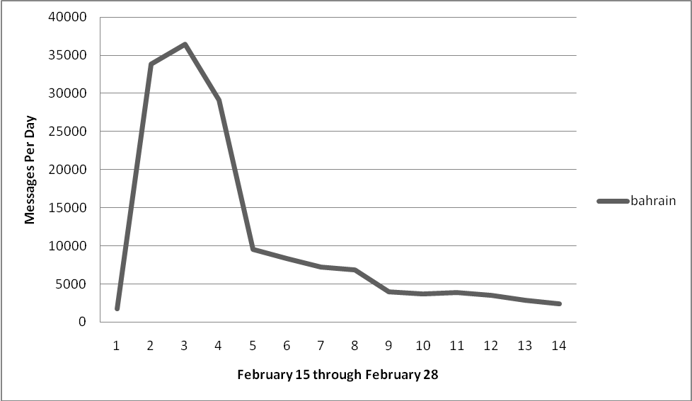
Figure 1. Number Twitter Messages Per Day Containing #feb14
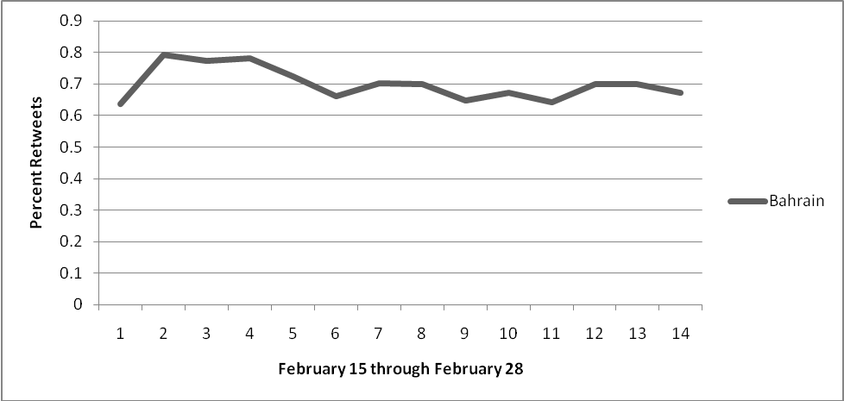
Figure 2. Percentage of Messages That Are Retweets for #feb14
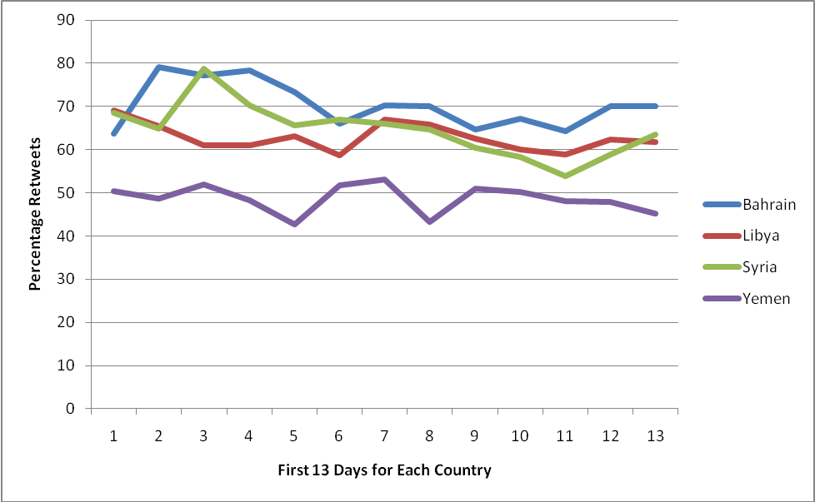
Figure 3. Percentage of Messages About The Four Countries That Are Retweets
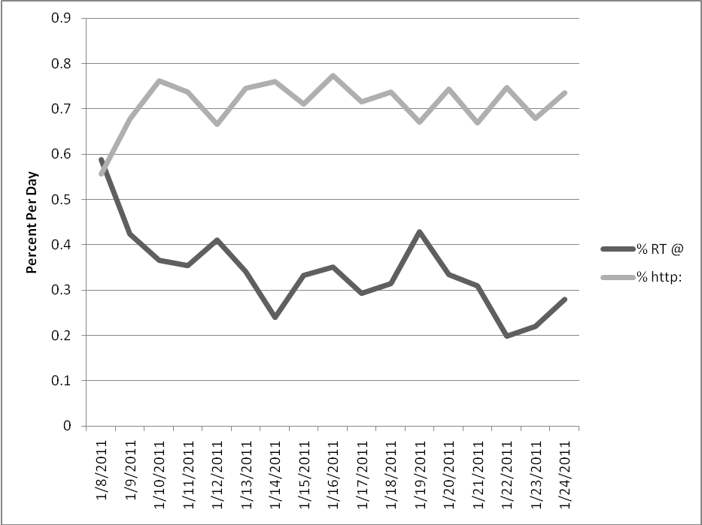
Figure 4. Giffords Shooting: Percentage Messages That Are Retweets or Contain urls
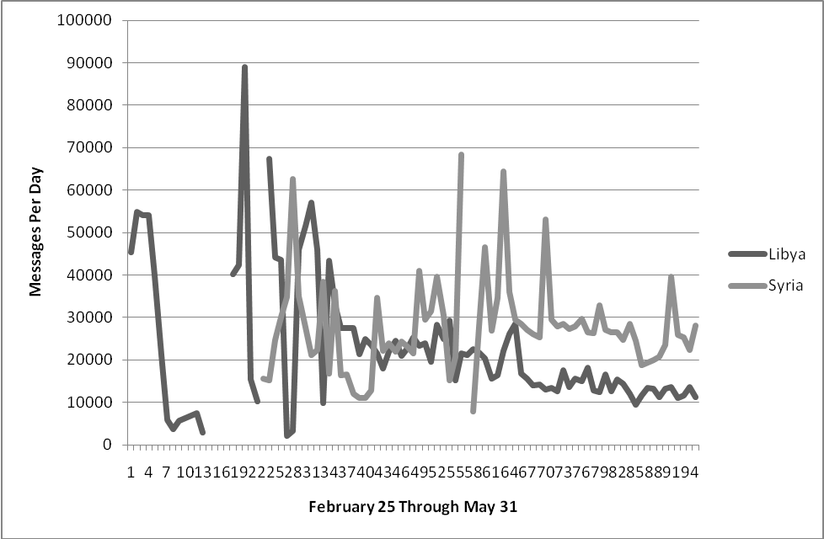
Figure 5. Twitter Messages Per Day for Libya and Syria February 25 Through May 31
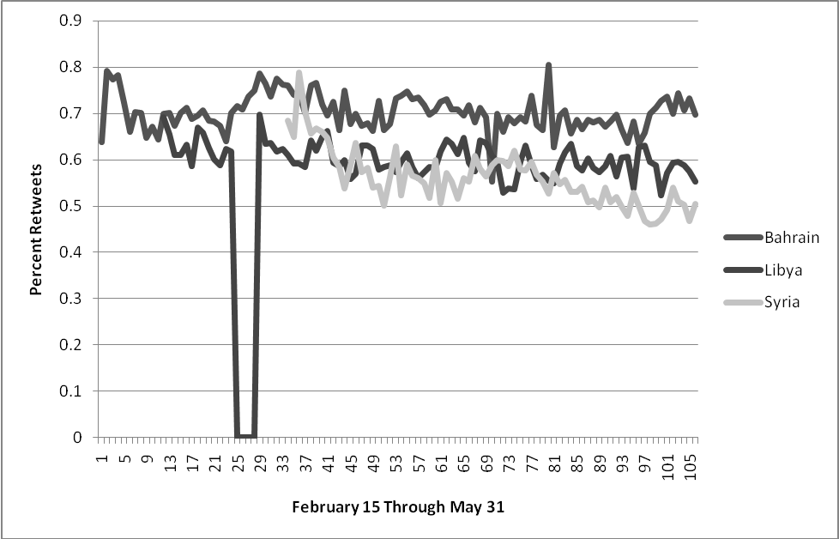
Figure 6. Percentage Twitter Messages About Three Countries That Are Retweets

